**DOCUMENT UNDERSTANDING**

Contents

Introduction 1

Taxonomy 3

Digitize: 11

Packages to be installed: 14

Activities used: 14

Extract Table data 21

Confidence score 24

Notes: 27

# Introduction

<https://www.youtube.com/playlist?list=PLhTE7-JU1rhYX6RmzEsCRSGqjyJIaKlG6>

Is an ability or a technique using which we can extract data. In case of unstructured

or semi structured format where we will not be able to extract data from it, document.

understanding uses AI to interpret information.

When we are given a paragraph to read, we read it and understand what is.

Reading or extracting data is easy but interpreting info from a paragraph interpreting.

meaning from scanned docs these all uses AI techniques which is in total called as

Document understanding.

Document understanding is an ability to extract data interpret information and

meaning out of it using AI techniques.





**Rule based** data extraction is where we use selectors regex data positions and **data variables model based** data extraction is where we use machine learning techniques to identify the data if it is semi or unstructured. **Mixing rule based** and **model based** gives the hybrid type of data extraction.





# Taxonomy

**Taxonomy here means organizing the documents.**

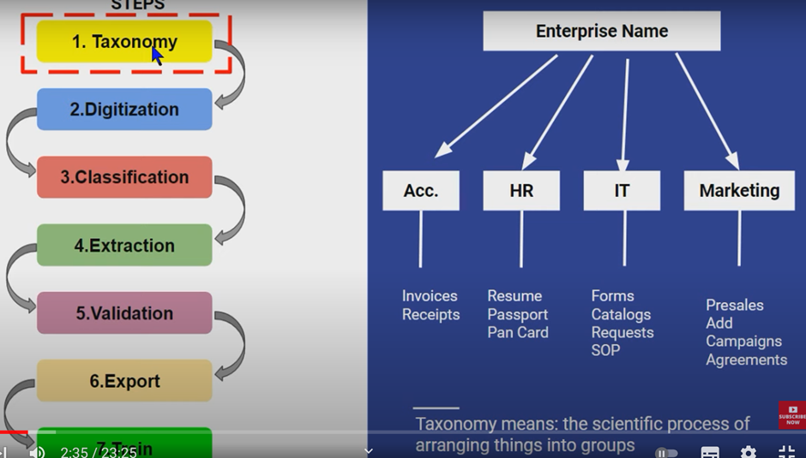

A company will be dealing with various kinds of documents depending on various departments it has. It has specific ways to organize all these documents.



In the ribbon you can see the new functionality added. taxonomy manager.



Activities

 

Click on the functionality taxonomy manager.



Once u click, Taxonomy. JSON file will get created. Whatever you are going to create it will be stored there.

Add group called enterprise name. add category called accounts, IT, HR, and so on.

Add Document type.

Here we are just creating structures.



Once you click on Save, you can find this.



We can also add other kind of receipts under Document type. Below you can see mini document types under many other categories.



If we just click on any category, we can see all the categories and all the documents

under that category.



Now we have finished the very first step. installing the package and creating

taxonomy.

There are 2 steps in taxonomy

Create & load

In the above steps, we have already created the structure of documents & defined

the types. Now we need to create the fields that we want to extract after which we

can load. We need to define what all fields we need as in the below 2nd image.





Type the field names that you need, it doesn’t require exact name as in the

document. Also define the type as below & save.



Create as many fields as you want as below.



Creating & defining is the 1st step of Taxonomy, which is done, lets load by using the

activity “Load Taxonomy”

Before that go to the projects tab and click on refresh. You will see document.

processing folder. Inside that there will be taxonomy Json file. Load taxonomy is the

activity that is going to interact with taxonomy json file. If you open the taxonomy file

you can see the below.



What is the use of load taxonomy activity?

Once you create taxonomy, everything will get stored in the taxonomy Json file. If

you want to use something from that file, or extract data from that file, to have it

loaded into a variable, we will use this activity.

Just create a variable using Control+K and you can see the below.





1. There are 7 steps: Taxonomy, Digitization, Classification, Extraction, Validation,

Export & Train.

2. Taxonomy means arranging anything in a group manner. Arranging something in

a grouped way. In UiPath DU, we organize all the document types, we group

them which is possible by taxonomy. We do this in Taxonomy manager where we

can organize all the doc types.

3. UiPath. IntelligentOCR. Activities package

4. Created when we go to taxonomy manager & create Group name, category, doc

type and fields names. As and when we edit or update the document, it gets

saved. It is a file that contains all the details of how we have organized the

taxonomy manager.

5. Once JSON file gets created through Taxonomy manager, to read this JSON file,

this activity helps to extract data and load it to a variable.

# Digitize:



Activity: Digitize document



DOM contains all the details like position, number of pages, etc.

To use OCR engine, install package called omnipage.



Use OmniPage OCR engine



# Packages to be installed:

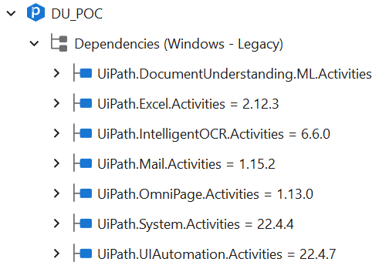

1. UiPath.DocumentUnderstanding.ML.Activities
2. UiPath.IntelligentOCR.Activities
3. UiPath.OmniPage.Activities

# Activities used:

1. **Load Taxonomy:** loads the created taxonomy into a variable for further steps use

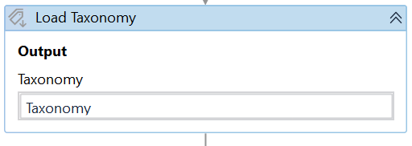

1. **Digitize Document**: It converts digital (doesn’t use OCR) and non-digital document (uses OCR) data into text and DOM. Since we are looping through many files, “Document Path” is having the value item as we are using this activity inside For each item in ListOfFiles loop

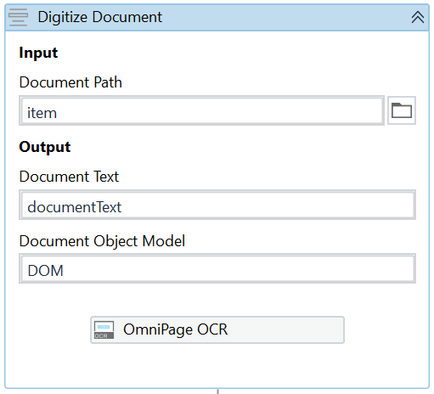

1. **Classify Document Scope:** is to make sure the documents are classified correctly based on the keywords that we give. For example, keyword “Invoice” will help the bot understand that it is dealing with the Invoice document, keyword “form” will help the bot understand that it is dealing with the “Forms” type of document.

The classifier used here is “keyword-based classifier”. *We need to create an empty Json file and pass the path here in this classifier for it to store the details.*

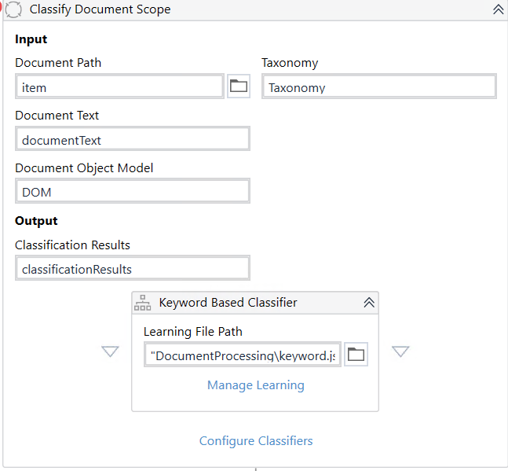

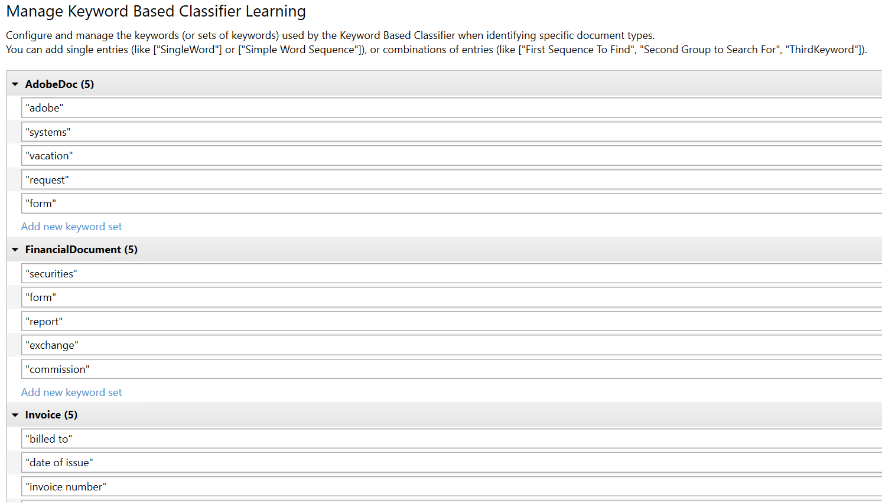

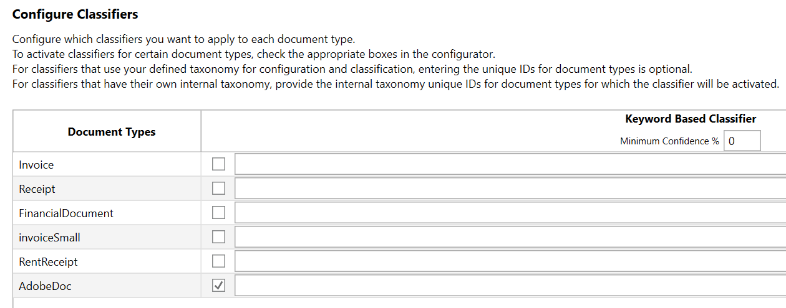

1. **Data Extraction Scope:** this will extract the required data based on what values we are configured in the extractors used in the scope.

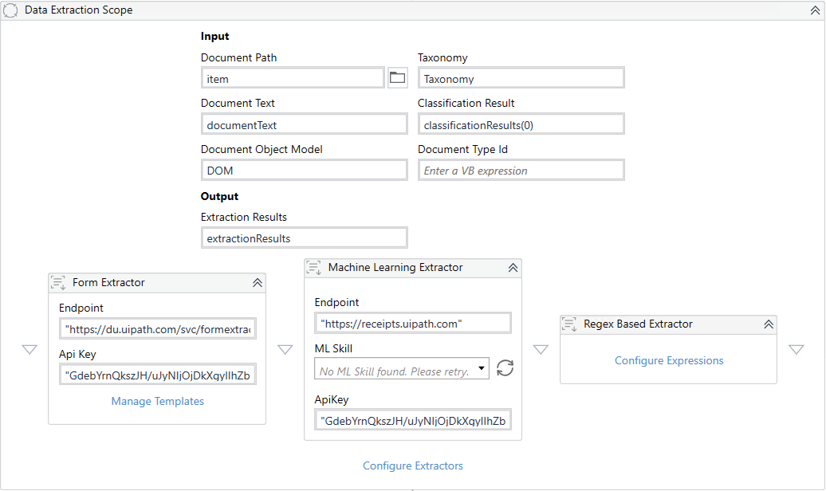

1. Form extractor:

Endpoint will automatically popup.

Api key will be present in the orchestrator admin licenses.

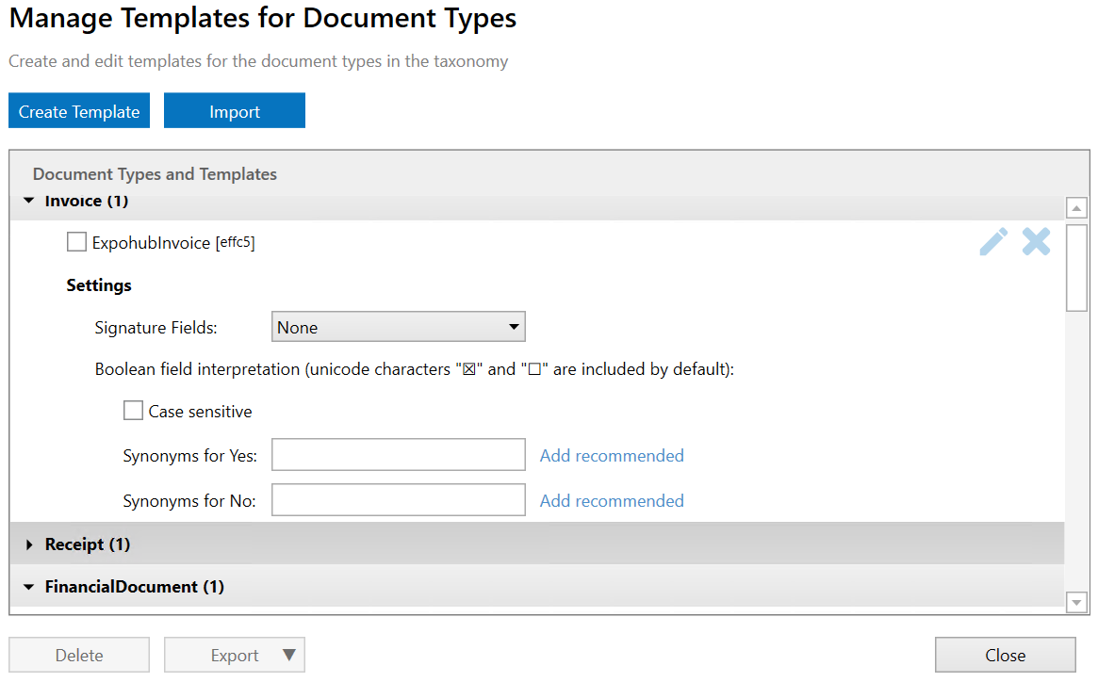

We need to create template by adding the following details & uploading a sample file so that bot will recognize it and deal it as configured by us

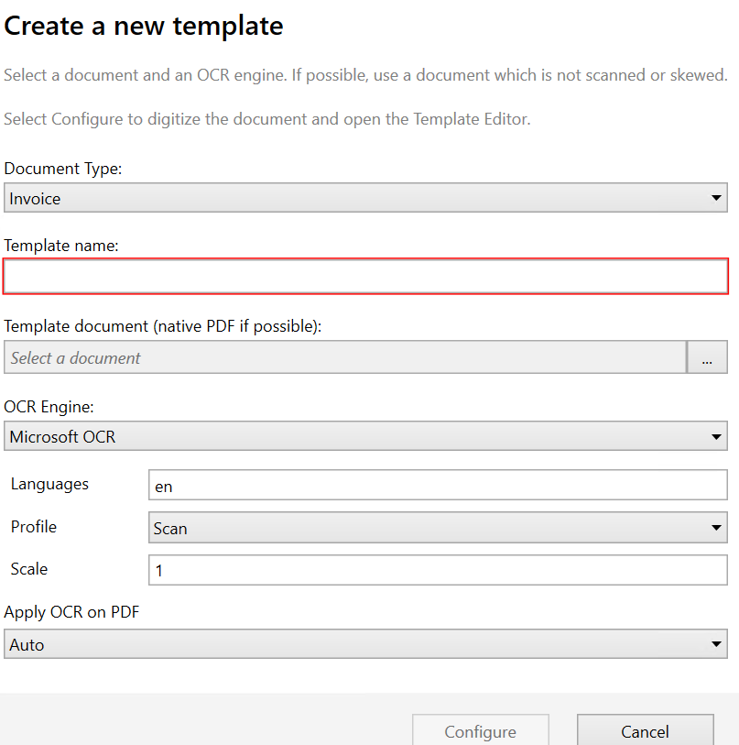

1. Machine learning Extractor:

Endpoint needs to be given based on the type of document we are dealing with, example invoice, receipt.

Api key will be present in the orchestrator admin licenses.

1. Regex Based Extractor: configure expressions:

We must write regex expressions to extract the data

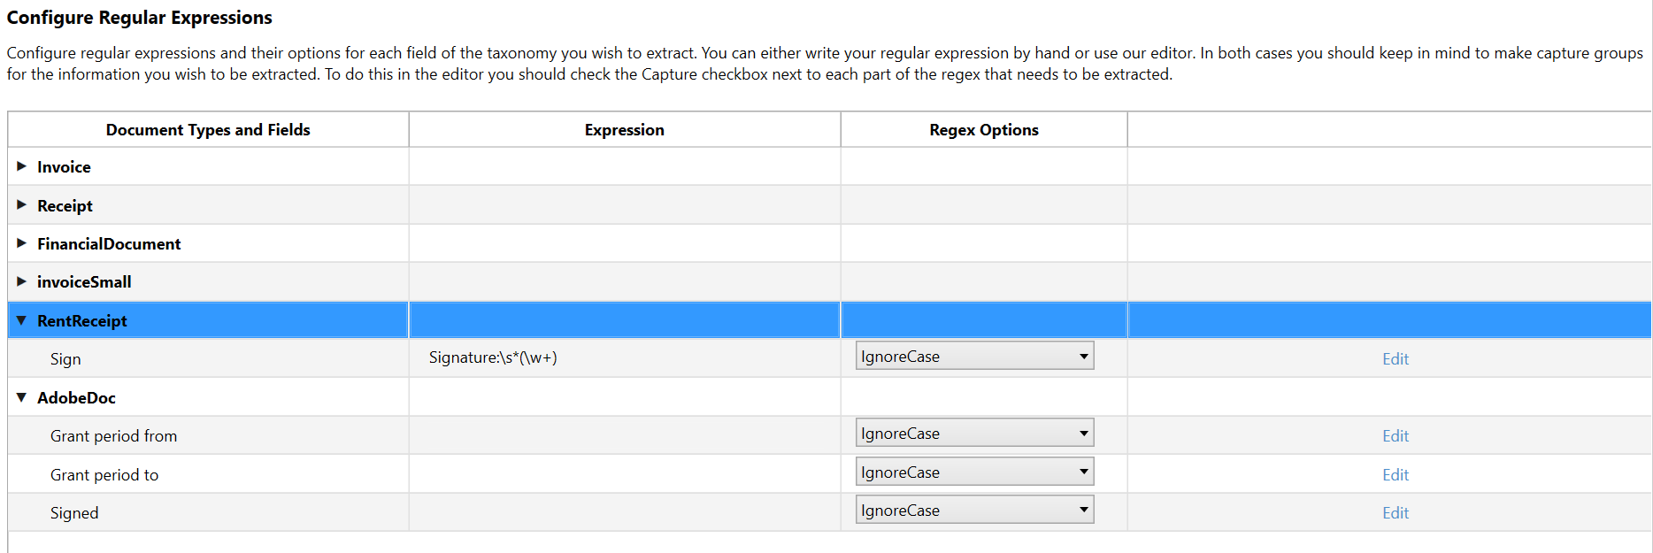

Click on Edit & create Regex expressions

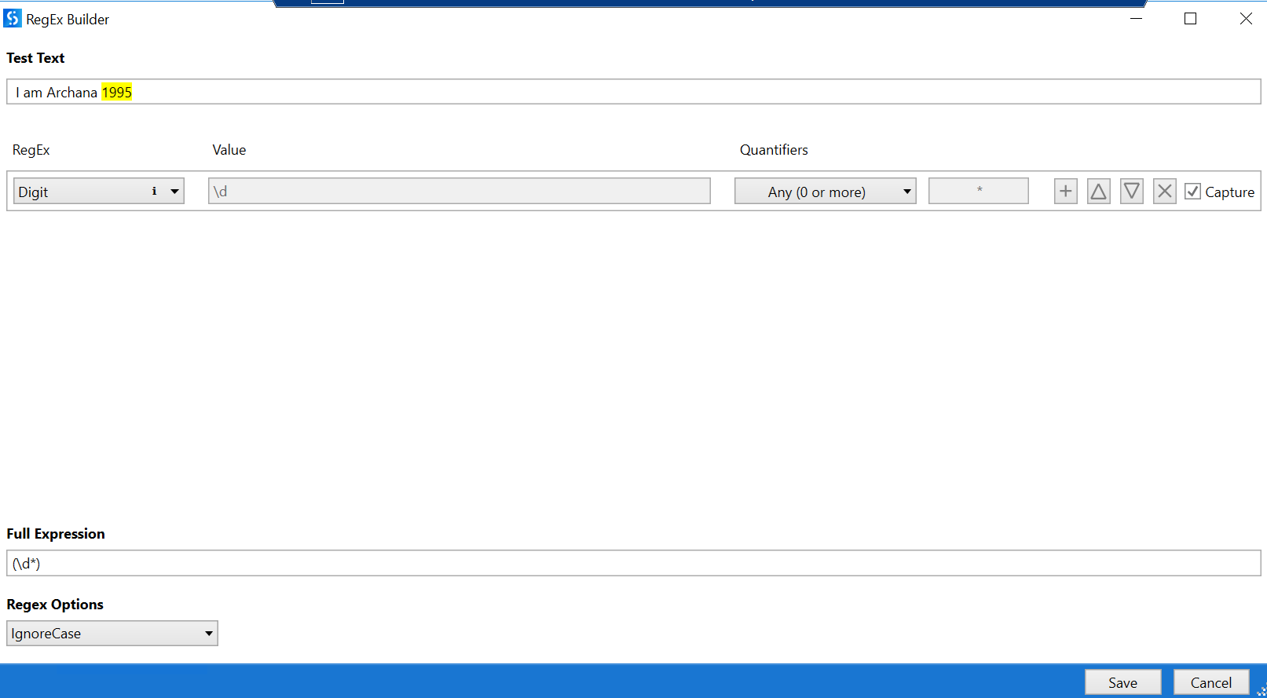

1. Configure Extractors:

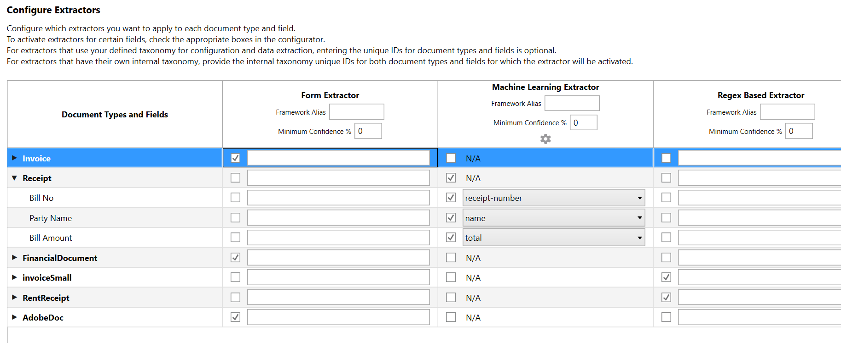

We need to configure which extractor will work for which document type by checking the box as above.

Machine learning extractor will have its own set of keywords to match with what we want to extract. These keywords in the dropdown will be available because of the specific endpoint we give while using this extractor.

1. **Present Validation Station:** to make sure that human validates the bot run and confirms the data. *This will be used only while testing and not in production.*

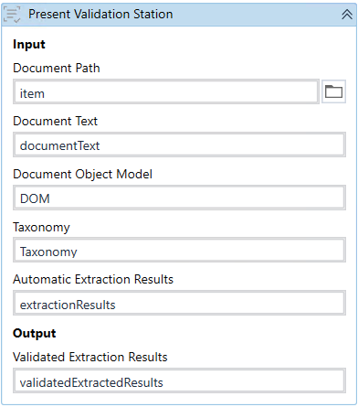

1. **Export extraction results:** will help us extract the results got from the above steps. Here dataset variable is nothing but collection of tables (explained descriptively in the next topics)

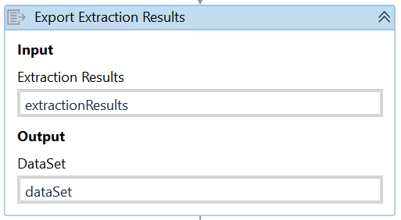

Merge data table will merge the extracted results into the already created data table

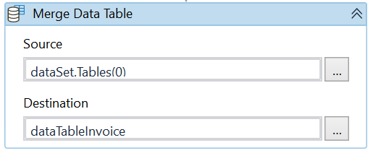

***NOTE****: If we are using different types of documents, then the data extracted also will be different with different number of columns. In this case, instead of merging the data into same data table, we can use write range and write the extracted data and keep it aside without disturbing the next data*

# Extract Table data

1. Add the field called Table and select the type as table in taxonomy & add whatever columns you need from the table.

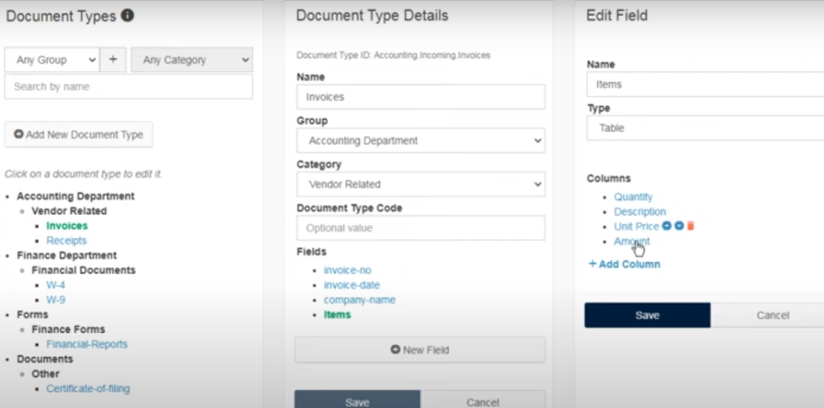

1. In the Extraction scope, algorithm will be written in the backend, our only job is to select. We need to go to “Configure extractors” option.

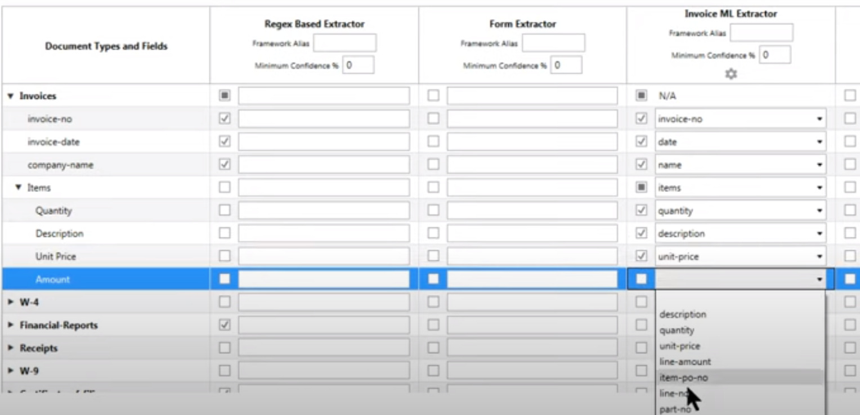

1. During Validation station, the extracted table will be shown in the right down part of the window.

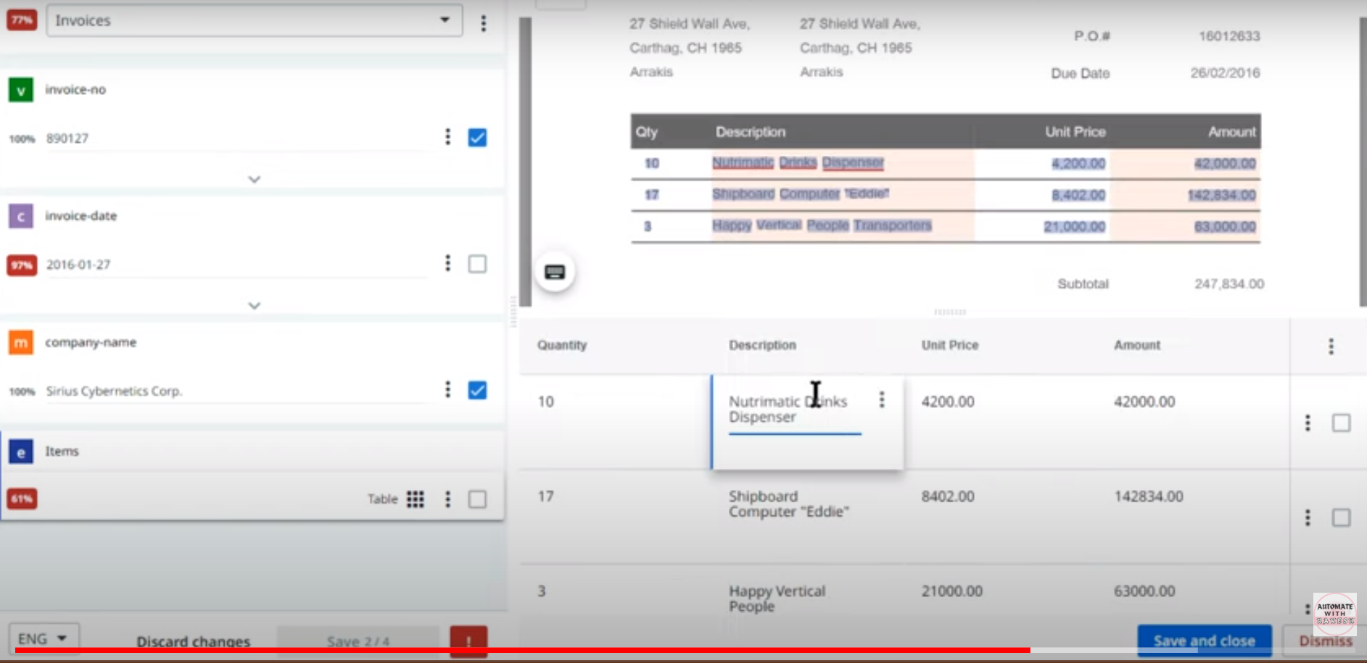

If data is not getting pulled properly from table, then go to 3 dots at the right.

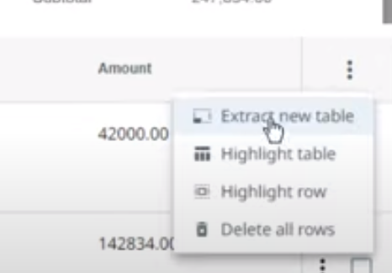

Just click on “Extract new table” & highlight the specific area which you want to extract like below. Before saving look the below point.

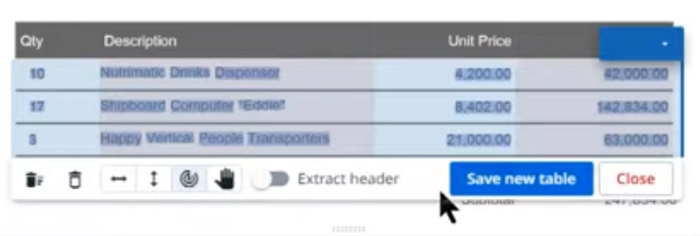

Drag the right line and separate columns.

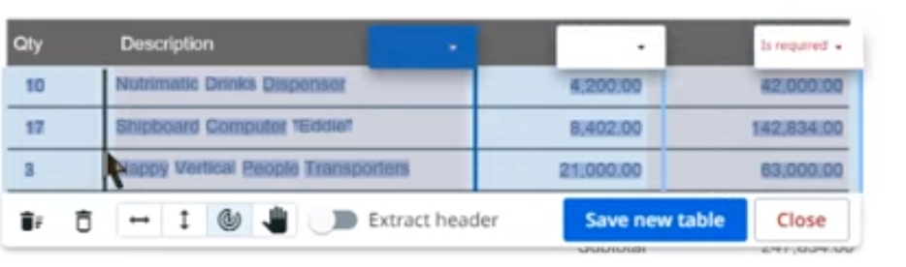

And manually select the column names

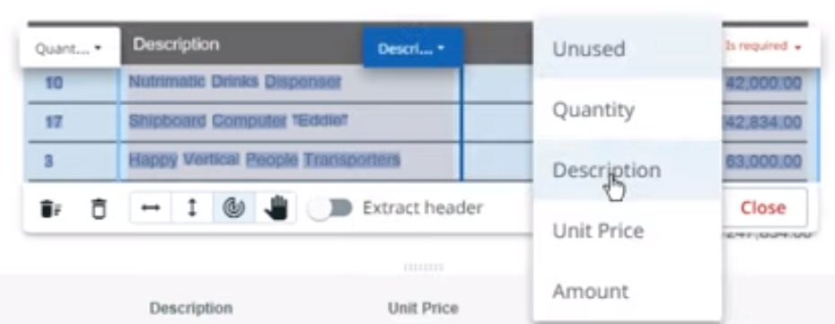

# Confidence score

This helps us understand the accuracy of the data extracted & find out if any inaccurate data has extracted. We can write the confidence score of each field we extract like below.



Depending on our threshold, we can compare the confidence & determine the accuracy of the extracted data. If the value is 1, it means it is 100% accurate.

Output of Data extraction scope is extractionResults & it gives Confidence score saying how confidence it is on the extracted data. We need to know how to exercise with that confident score.

After data extraction, lets write the output in text file.

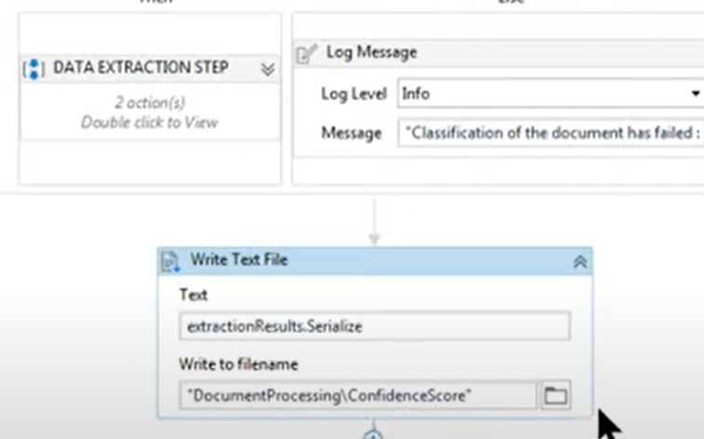

This text file will be like below with lot of data

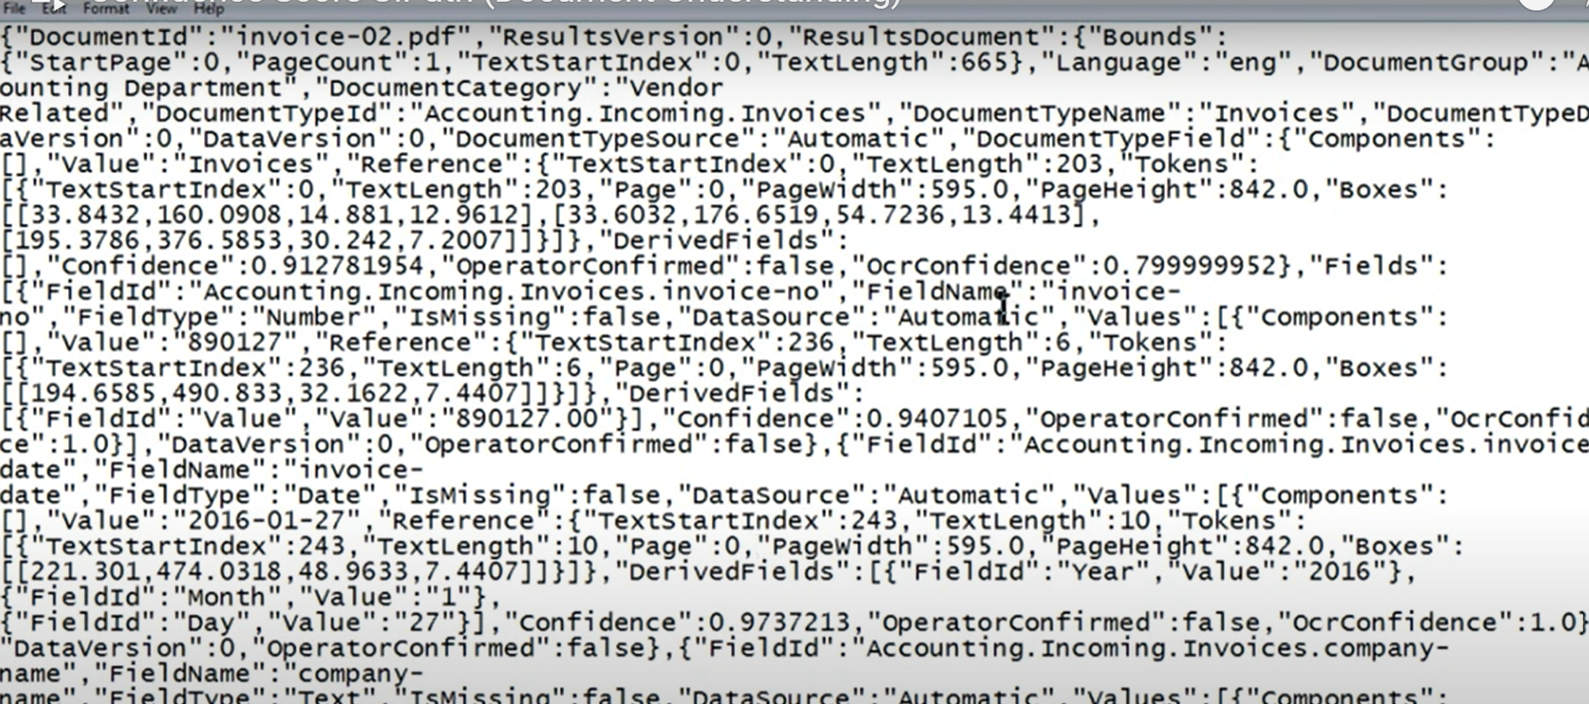

If you separate as per the field names like below, we get confidence score for each field.

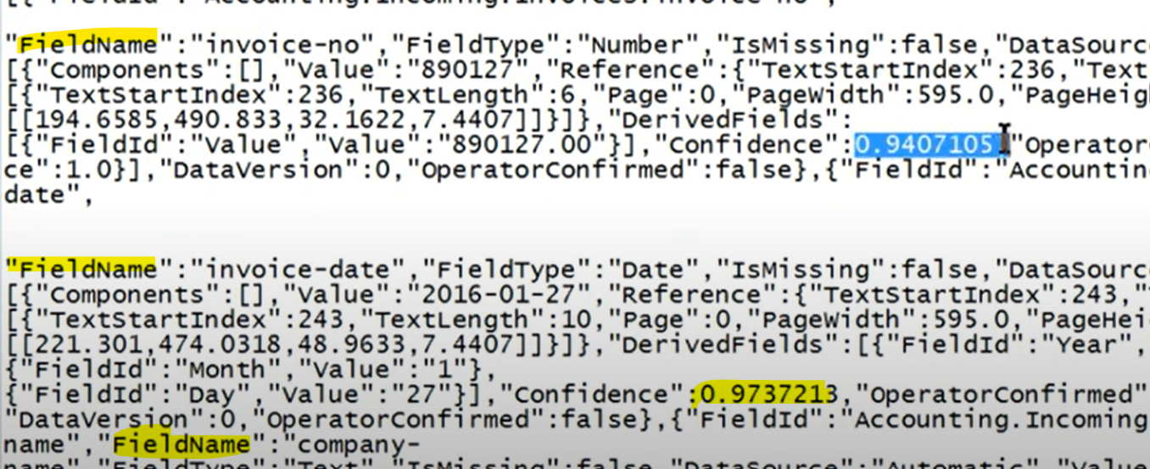

Lets export the data like below instead of DataSet.Tables(0) & check if it gives confidence score in the columns after every field.

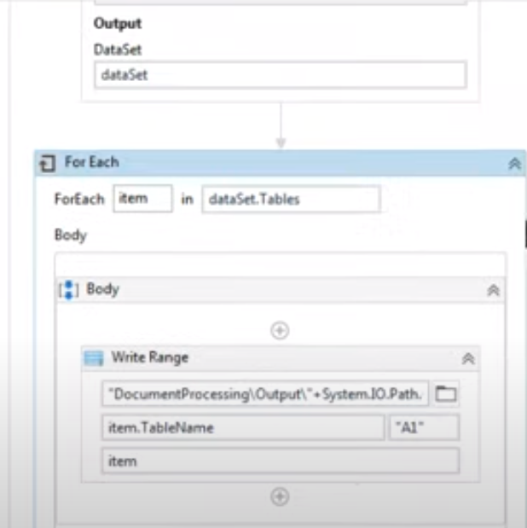

Now, drag the write text from under data extraction & place under validation step & take validated results as input. Also in export.

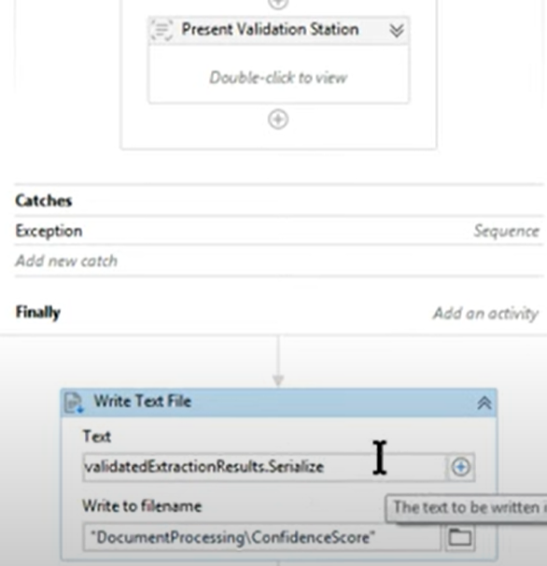 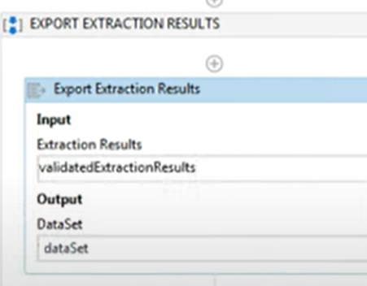

Now you see, the confidence level will be 1 and it is 100% because we have validated in the validation station & post that it is taking as 100%

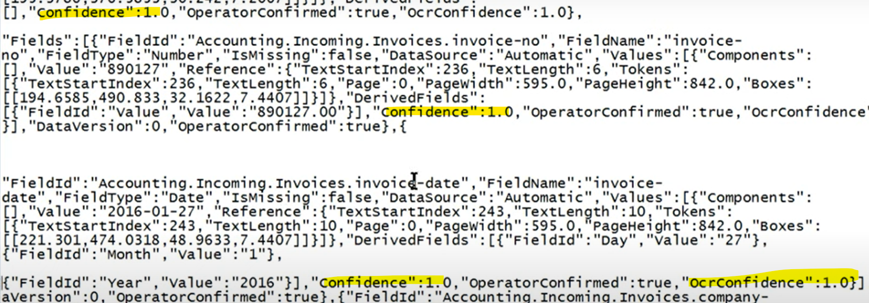

Even in the output excel it is marked as 1

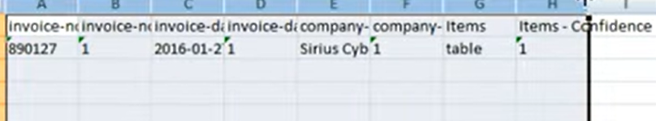

# Control Present Validation Station

After extraction scope, place for each loop. For each item in extractionResults.ResultsDocument.Fields. Set the type argument as below

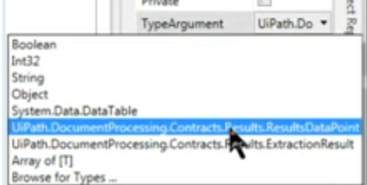

We want to see the confidence of the items so I have written item.Values(0).Confidence in below code.

Code says, if confidence is less than 96% then open validation station.

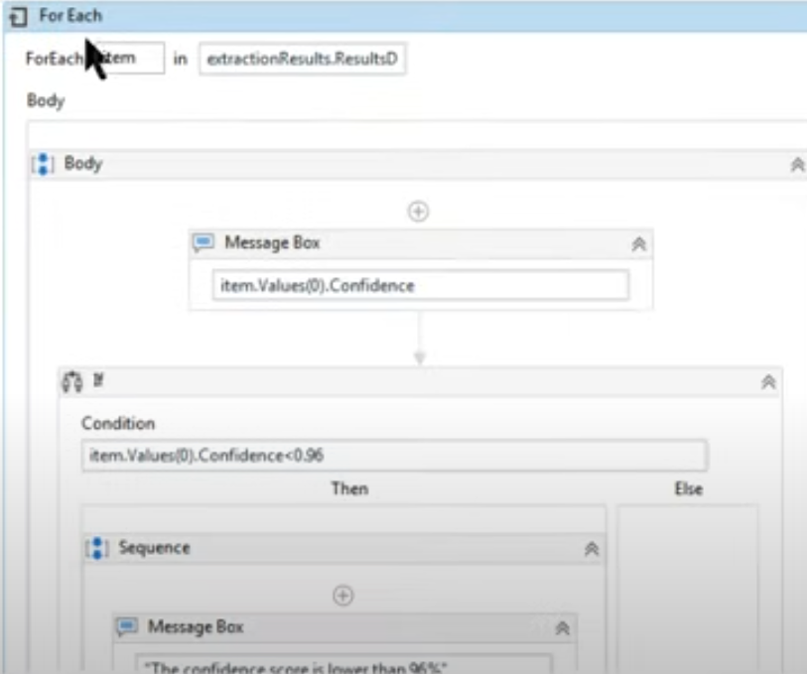

If validation happens, then validated results will be exported, else extracted results

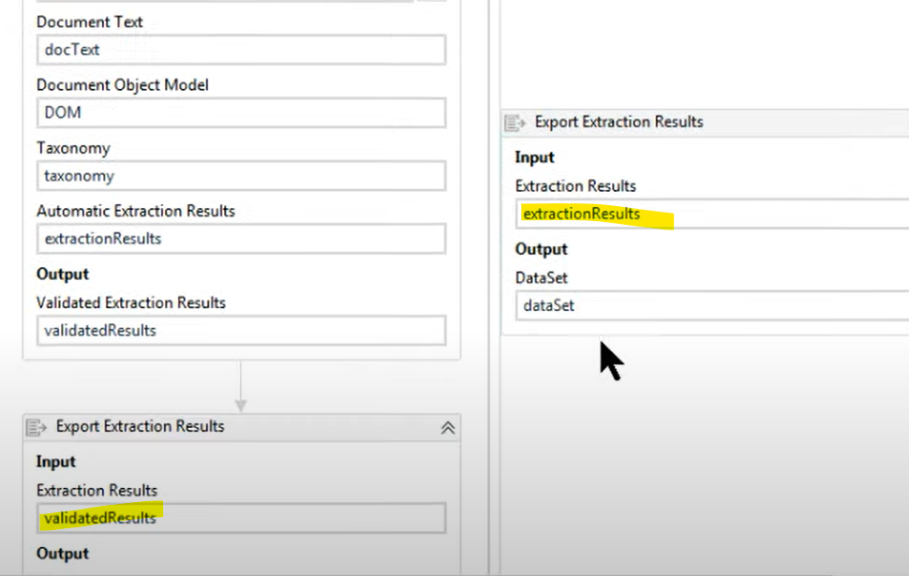

# Read Checkbox Using DU

1. Below is the sample w9 doc.

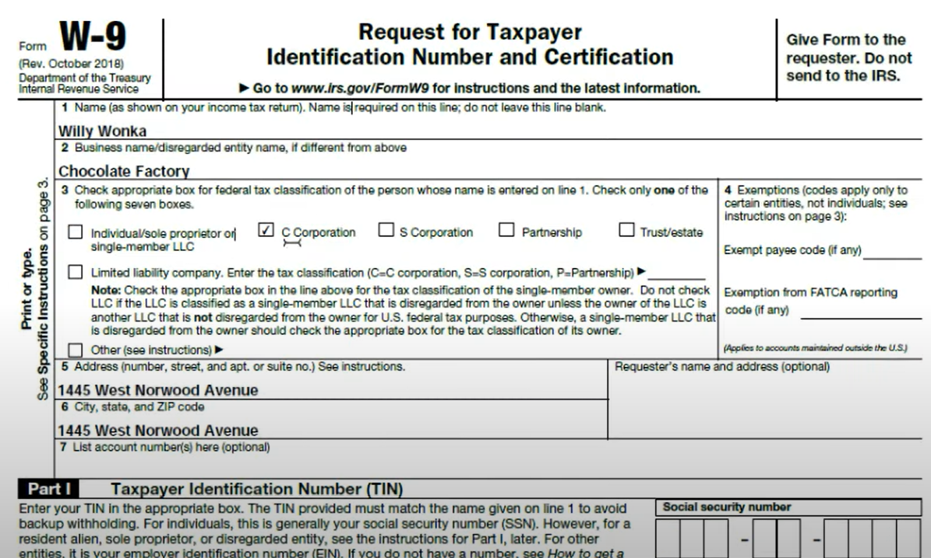

1. In taxonomy, enter the checkbox field name which you are interested in to work with

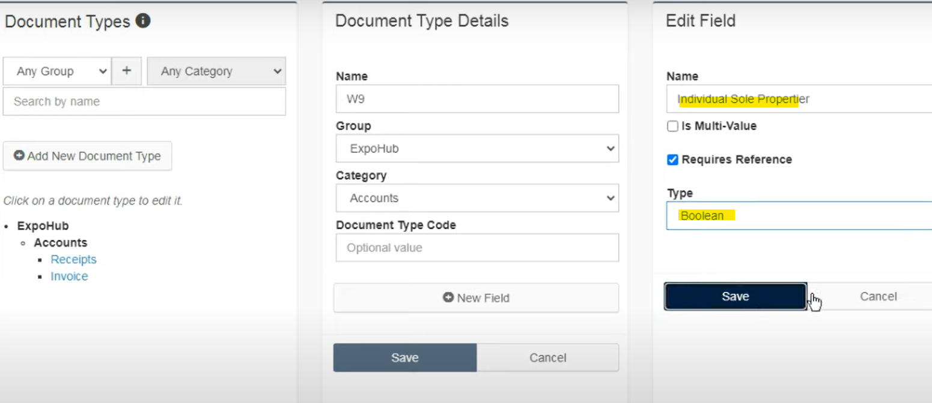

1. Digitization & classification will be done. Extractor used will be FORM extractor as it is best suited for forms. Create template.

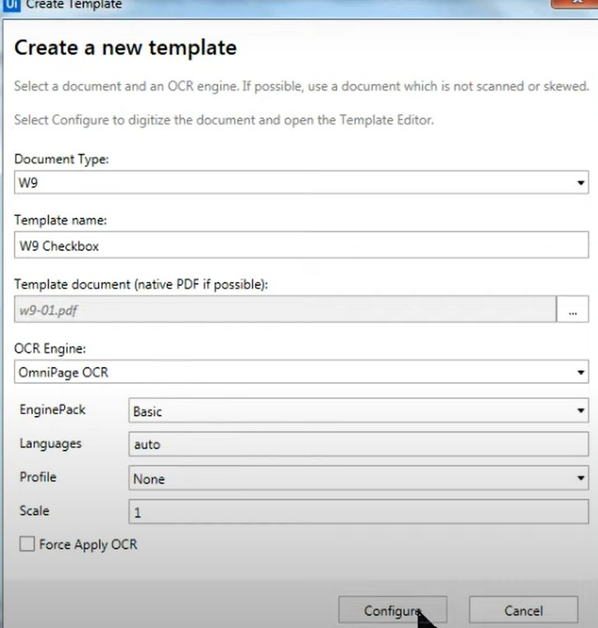

1. Now we need to indicate the matching info. Select the field’s corresponding checkbox and add it in the left pane + symbol adjacent to the field.

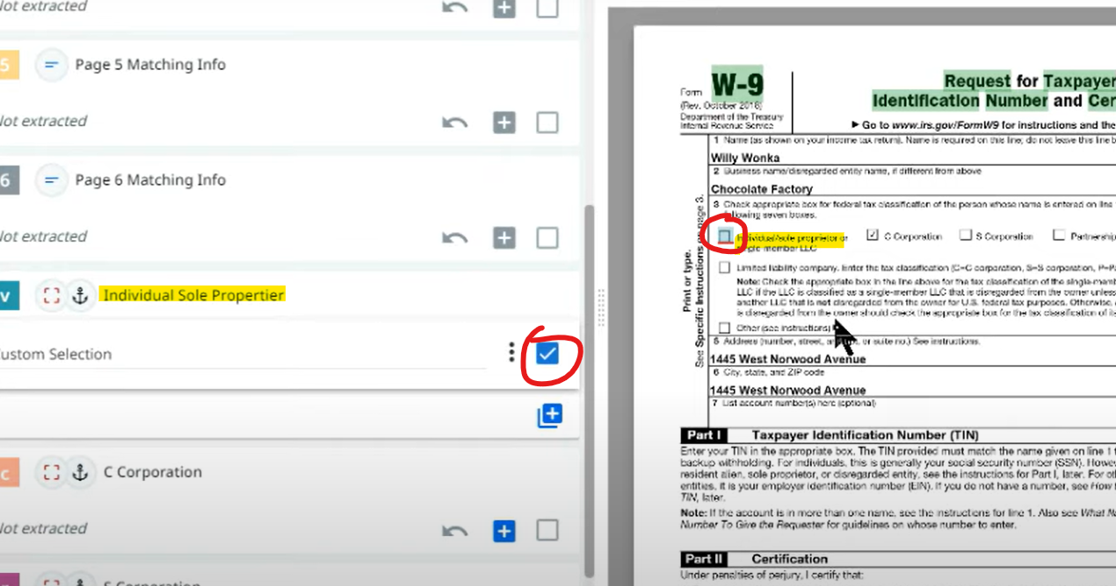

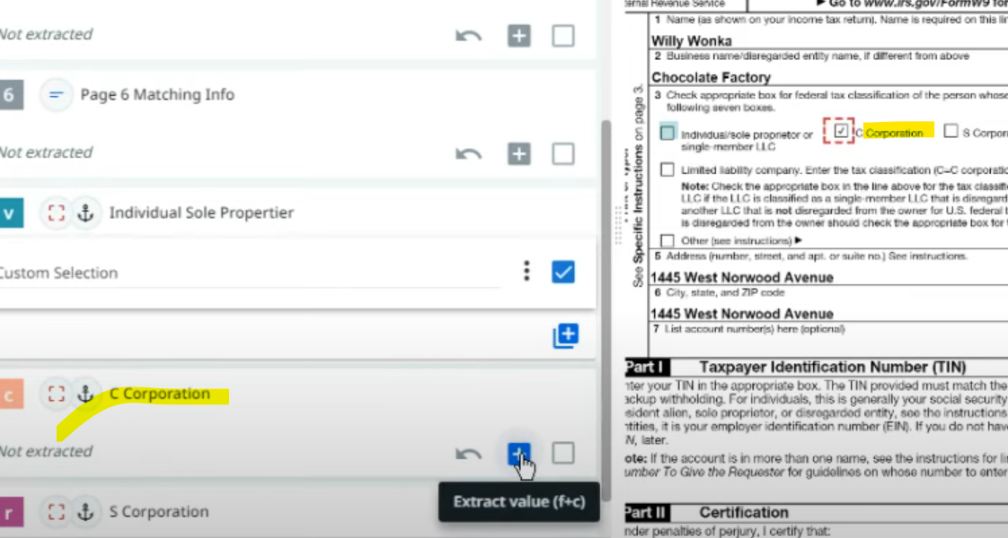

1. When you run the code, validation station looks like below.

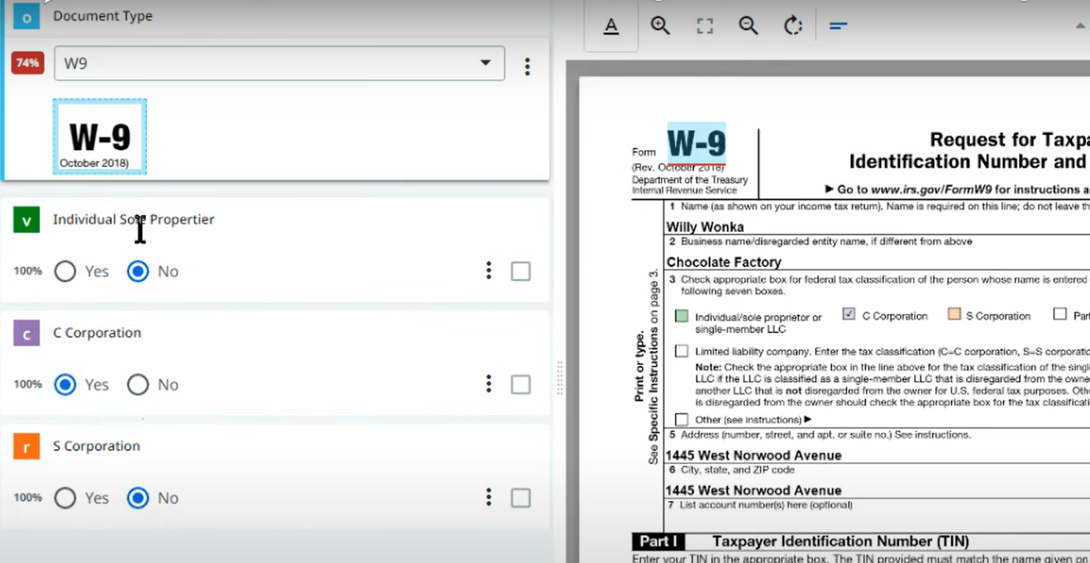

# Notes:

ML:

1. Endpoints are as below. In google- search public endpoints uipath docs

<https://docs.uipath.com/document-understanding/automation-cloud/latest/user-guide/public-endpoints>

"https://invoices.uipath.com"

"https://receipts.uipath.com"

Accounts, finance: https://du.uipath.com/ie/invoices

"https://du-us.uipath.com/ie/invoices"

"https://du-us.uipath.com/ie/receipts"

1. Form Based extractor: Endpoint is already generated
2. **API key (same to all) -> Cloud.uipath.com -> admin -> Licenses -> Robots & Services -> DU -> Copy API key**

**"6Pp3TgpjRzY8ydf2zUXzTVADsjFq/qeDTfR+IpYgxweqiQHb0/zkOJ5dvnU0tDZzInb8zpywVTDhUHuV44+bVw=="**

**Extract handwritten text**

**Signature comparison**

If you are using the paid OCRs then yes we need licenseIf you use Uipath Document OCR, then you can provide the API from the DEV orchestrator info as it will be available for every admin created in the orchestratorIf you use Omnipage OCR then no need to give API